CORCOVADO WILDERNESS LODGE
2027 Pacing & Revenue Outlook
Month-by-month analysis, reliability of the projection, opportunities and risks
Report to the Board of Directors
Prepared by: Finance — The Costa Rica Collection
Data as of: 30 September 2026 (Opera History & Forecast and Reservations Entered On)
Metric: Total Revenue · Projection method: availability (fill rate of free rooms)
Confidential — for Board use only

Contents
1. Executive Summary
Part I — Rooms Only
2. Rooms Only Analysis: 2026, On the Books 2027, Forecast and Rates
Part II — Total Revenue
3. Starting Point: The 2026 Base
4. 2027 Position at a Glance
5. Why the Projection Is a Reliable Planning Parameter
6. Month-by-Month Analysis (January–December 2027)
7. Total Revenue Opportunities
8. Risks and Watch List
9. Recommended Action Plan (next 90 days)
Appendix A — Methodology and Glossary
Appendix B — Projection by Method, per Month
Appendix C — Data Sources

1. Executive Summary
As of 30 September 2026, Corcovado Wilderness Lodge has 2,437 room nights (RN) and $2,253,556 on the books for 2027, 22.3% of the year's capacity. Based on how 2026 actually filled from the same date, Finance projects 2027 at 5,786 RN (52.8% occupancy) and $5,395,951 of total revenue: +17% in room nights and +10% in revenue versus the 2026 close of 4,958 RN and $4,897,469.
Rooms Only comes first because it is the core of the business and the line the rate strategy controls directly. 2026 Room Revenue is closing at $2,606,659 on 4,958 RN (ADR $526), against $2,625,131 in the 2026 Financial Forecast (ADR $586). For 2027, $1,213,119 of Room Revenue is on the books and the projection is $2,827,686 (ADR $489), +8% versus 2026.
Key messages — Rooms Only
- 2026 sold more rooms but at a lower rate than forecast: +11% in room nights, −10% in ADR, −1% in Room Revenue.
- Rate is the biggest Rooms opportunity. At the same 2027 volume, Room Revenue would be $2,976,281 at 2026's ADR (+$148,595) and $3,297,221 at the 2026 Forecast ADR (+$469,536).
- Booked rates are rising: paying reservations for January–April 2027 are 10–16% above the rates booked a year ago and 4–15% above the Budget 2027 net rate.
- What dilutes ADR is the nights at $0 (comps, house use, FAM, blocks): 14% of 2026 occupied nights, about 634 nights. Valued at the 2026 average paying rate ($672), that is $426,310 a year.
- Budget 2027 net rates applied to every projected night would give $3,791,180 of Room Revenue, $963,494 above the projection. The budget needs an allowance for $0 nights and group blocks.
Key messages — Total Revenue
- 2026 is closing at 4,958 RN and $4,897,469: 111% of the 2026 Financial Forecast in room nights (4,483) but 97% in revenue ($5,040,287), a gap of $142,818 driven by value per night.
- 2027 is starting ahead of 2026. Individual reservations are 1,283 RN versus 1,035 a year ago (pace 124%), plus 1,154 RN of group blocks.
- The first quarter is strong. January–March is projected at 83–91% occupancy, with 54–76% of each month already secured and booked rates 14–16% above the rates booked a year ago.
- The projection is achievable with known performance. 3,349 RN remain to be booked: 85% of the 3,923 RN that 2026 picked up from the same date.
- The projection is conservative. Of three standard methods, the one used is the lowest: 5,786 RN, versus 6,212 (add pickup) and 8,498 (multiply by pace).
- Revenue grows less than volume: $933 per room night versus $988 in 2026. At 2026's value per night, 2027 revenue would be $5,648,801 (+$252,850).
- Budget 2027 room rates hold up: January–April bookings in Opera are 4–15% above the budget net rate. The risk is the 14% of nights sold at $0 in 2026.
- The green season and the end of the year need action now. May, June, August and September are under 45% projected occupancy. For November and December there are no individual reservations yet, only group blocks.
- Booking pace has slowed in the last two weeks: 72 RN were booked for 2027, versus 102 in the same window last year (−29%).
Headline figures
Indicator | 2026 close | 2027 on the books | 2027 projection | 2027 vs 2026
Room nights | 4,958 | 2,437 | 5,786 | +17%
Occupancy | 52.2% | 22.3% | 52.8% | 0.7 pts
Room Revenue (Rooms Only) | $2,606,659 | $1,213,119 | $2,827,686 | +8%
Rooms ADR | $526 | $498 | $489 | −7%
Total revenue | $4,897,469 | $2,253,556 | $5,395,951 | +10%
Revenue per room night | $988 | $925 | $933 | −6%
Share of projection secured | — | — | 42% | —
2026 close: eight actual months (January–August) plus the September, November and December projections; October is closed. 2027 room-night capacity is 10,950.
What we ask of the Board
- Endorse the projection as the planning parameter for the 2027 budget and cash-flow plan, to be updated monthly with each new Opera snapshot.
- Support a Rooms rate strategy that protects ADR in the high season (January–April) and reduces nights sold at $0, rather than discounting to fill.
- Approve a commercial plan for the need periods (May–June, August–September and November) to be launched in Q4 2026.

PART I — ROOMS ONLY

2. Rooms Only Analysis: 2026, On the Books 2027, Forecast and Rates
Room Revenue as posted in Opera's History & Forecast (Rooms Only report): room nights, Room Revenue and ADR, without food, beverage, activities or on-site spend. Everything in this part is Rooms Only; Part II repeats the analysis on Total Revenue.

2.1 2026 Rooms: actual versus the 2026 Financial Forecast
Month | Status | RN | Fcst RN | Room Revenue | Fcst Room Rev. | vs Fcst | ADR | Fcst ADR | ADR vs Fcst
Jan 2026 | Actual | 688 | 637 | $420,485 | $427,259 | −2% | $611 | $671 | −9%
Feb 2026 | Actual | 684 | 668 | $414,152 | $416,163 | 0% | $605 | $623 | −3%
Mar 2026 | Actual | 721 | 691 | $425,210 | $423,980 | 0% | $590 | $614 | −4%
Apr 2026 | Actual | 503 | 473 | $341,492 | $319,273 | +7% | $679 | $675 | +1%
May 2026 | Actual | 256 | 223 | $94,683 | $119,456 | −21% | $370 | $536 | −31%
Jun 2026 | Actual | 284 | 162 | $78,910 | $79,311 | −1% | $278 | $490 | −43%
Jul 2026 | Actual | 267 | 233 | $105,428 | $105,358 | 0% | $395 | $452 | −13%
Aug 2026 | Actual | 292 | 254 | $130,905 | $130,634 | 0% | $448 | $514 | −13%
Sep 2026 | Open | 229 | 44 | $19,410 | $20,000 | −3% | $85 | $455 | −81%
Oct 2026 | Closed | 0 | 0 | $0 | $0 | — | — | — | —
Nov 2026 | Open | 407 | 375 | $179,408 | $134,850 | +33% | $441 | $360 | +23%
Dec 2026 | Open | 627 | 723 | $396,577 | $448,849 | −12% | $632 | $621 | +2%
Total |  | 4,958 | 4,483 | $2,606,659 | $2,625,131 | −1% | $526 | $586 | −10%
Fcst = 2026 Financial Forecast, Room Revenue line (January–March actual, April–December forecast). September, November and December 2026 are still open: their figures are the 2026 projection.
- Volume beat the forecast in every month from January to November, but ADR fell short in 7 of the 8 closed months. The gap is largest in the green season: May −31%, June −43%, July −13%.
- The high season held its rate better: April was in line with the forecast ADR and January–March were 3–9% below it.
- September 2026 shows $85 of Room Revenue per night (229 RN, $19,410). This looks like a posting issue in Opera and should be reviewed before the month closes.

2.2 2027 Rooms on the books versus 2026
Month | OTB RN | OTB Room Rev. | OTB ADR | STLY RN | Pace | 2026 RN | 2026 Room Rev. | 2026 ADR | Proj. RN | Proj. Room Rev. | Proj. ADR | vs 2026
Jan | 590 | $379,561 | $643 | 410 | 117% | 688 | $420,485 | $611 | 772 | $490,653 | $636 | +17%
Feb | 550 | $319,153 | $580 | 218 | 177% | 684 | $414,152 | $605 | 767 | $450,705 | $587 | +9%
Mar | 428 | $227,926 | $533 | 202 | 112% | 721 | $425,210 | $590 | 786 | $438,986 | $559 | +3%
Apr | 172 | $86,679 | $504 | 72 | 151% | 503 | $341,492 | $679 | 551 | $343,950 | $624 | +1%
May | 77 | $28,597 | $371 | 47 | 74% | 256 | $94,683 | $370 | 279 | $103,271 | $370 | +9%
Jun | 53 | $25,399 | $479 | 10 | 110% | 284 | $78,910 | $278 | 314 | $97,852 | $312 | +24%
Jul | 324 | $131,298 | $405 | 21 | 143% | 267 | $105,428 | $395 | 493 | $197,962 | $402 | +88%
Aug | 72 | -$6,979 | -$97 | 4 | 150% | 292 | $130,905 | $448 | 403 | $141,318 | $351 | +8%
Sep | 0 | $0 | — | 3 | 0% | 229* | $19,410 | $85 | 326 | $27,628 | $85 | +42%
Oct | 0 | $0 | — | 0 | — | 0 | $0 | — | 0 | $0 | — | —
Nov | 66 | $2,468 | $37 | 43 | 0% | 407* | $179,408 | $441 | 436 | $165,460 | $380 | −8%
Dec | 105 | $19,018 | $181 | 5 | 0% | 627* | $396,577 | $632 | 660 | $369,901 | $561 | −7%
Total | 2,437 | $1,213,119 | $498 | 1,035 | 124% | 4,958 | $2,606,659 | $526 | 5,786 | $2,827,686 | $489 | +8%
OTB includes group blocks, which in Opera carry little or no room revenue until the rooming list is entered. That is why OTB ADR is low in July, August, November and December (August shows a negative OTB Room Revenue in Opera, a data issue). The projection values new nights at each month's 2026 ADR. * = 2026 month still open.
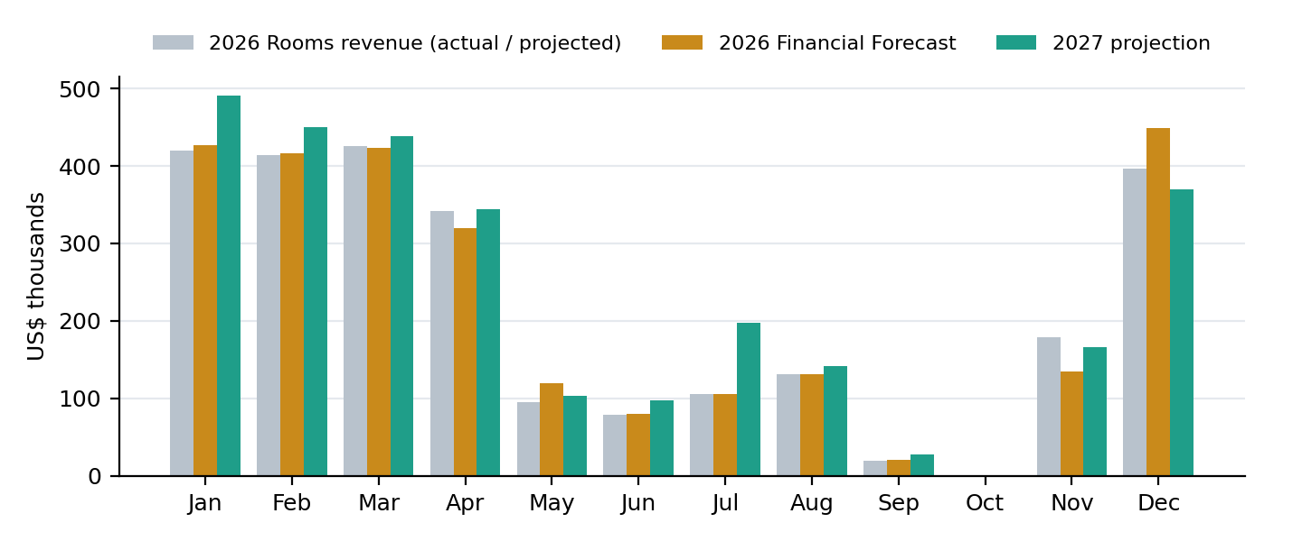
Figure R1 — Room Revenue by month: 2026 (actual or projected), 2026 Financial Forecast and 2027 projection (US$ thousands).
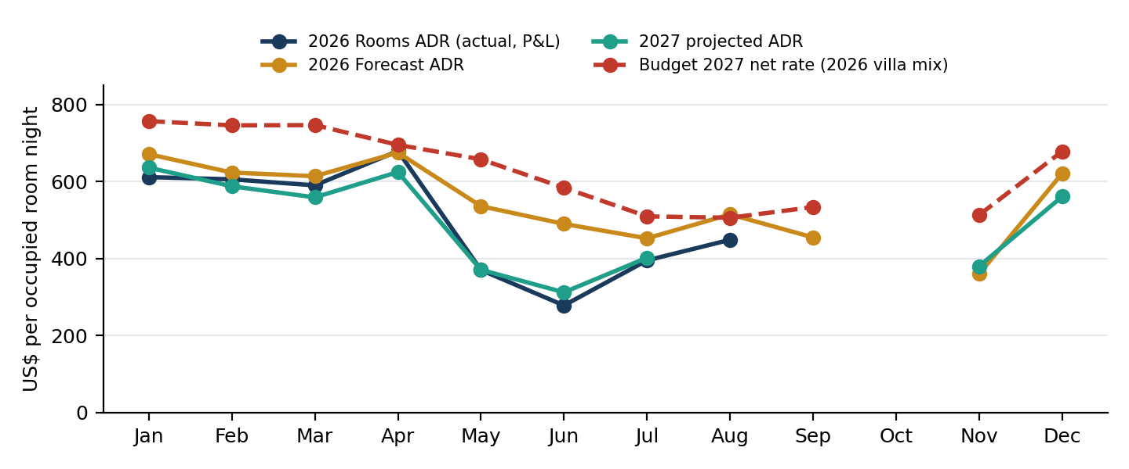
Figure R2 — Rooms ADR by month: 2026 actual, 2026 Forecast, 2027 projection and the Budget 2027 net rate. The space between the lines is the rate opportunity — and the budget risk.

2.3 Rooms Only opportunities
Same projected 2027 volume (5,786 RN), different ADR assumptions:
Scenario | Rooms ADR | Room Revenue 2027 | vs projection
Projection (each month at its 2026 pickup ADR) | $489 | $2,827,686 | —
Each month at its 2026 actual ADR | $514 | $2,976,281 | +$148,595
Each month at the 2026 Forecast ADR | $570 | $3,297,221 | +$469,536
Budget 2027 net rate on every night | $655 | $3,791,180 | +$963,494
The last row is not an opportunity but a warning: it is what the budget produces if its net rate is applied to all occupied nights, including comps, $0 nights and group blocks.
Month | Proj. occ. | Proj. ADR | 2026 ADR | Fcst ADR | To 2026 ADR | +5 pts occupancy | +5% rate | 2026 nights at $0
Jan | 83.0% | $636 | $611 | $671 | — | $29,562 | $5,778 | 8%
Feb | 91.3% | $587 | $605 | $623 | $13,864 | $24,671 | $6,381 | 6%
Mar | 84.5% | $559 | $590 | $614 | $24,487 | $25,974 | $9,995 | 6%
Apr | 61.2% | $624 | $679 | $675 | $30,094 | $28,093 | $11,829 | 6%
May | 30.0% | $370 | $370 | $536 | — | $17,218 | $3,738 | 16%
Jun | 34.9% | $312 | $278 | $490 | — | $14,034 | $4,066 | 45%
Jul | 53.0% | $402 | $395 | $452 | — | $18,678 | $3,391 | 17%
Aug | 43.3% | $351 | $448 | $514 | $39,257 | $16,314 | $5,803 | 16%
Sep | 36.2% | $85 | $85 | $455 | — | $3,814 | $1,381 | 83%
Nov | 48.4% | $380 | $441 | $360 | $26,629 | $17,088 | $7,020 | 3%
Dec | 71.0% | $561 | $632 | $621 | $47,389 | $26,069 | $15,552 | 2%
Total | 52.8% | $489 | $526 | $586 | $148,595 | $221,518 | $74,934 | 14%

Where the Rooms upside is
- Recover the 2026 ADR month by month: +$148,595. The projection already carries a lower ADR than 2026 because the nights on the books include group blocks with little room revenue; converting those blocks at contract rates closes most of this gap.
- Reach the 2026 Forecast ADR: +$469,536. This is the rate level Finance planned for 2026 and did not achieve, mainly in May–August.
- Reduce nights at $0: 634 nights in 2026 (14%). Every 100 of them sold at the 2026 paying average is about $67,241. Put a monthly cap on comps, house use and FAM nights in the high season.
- Occupancy in the green season: each 5 occupancy points across the open months is worth $221,518 of Room Revenue; May, June, August and September carry the most unsold rooms.
- Villa pricing: Carate and Agujas already sell 12% and 27% above their budget pair (Corcovado and Sirena). Pricing them separately captures that premium explicitly.

2.4 Room rates: Budget 2027 vs Opera and 2026 actual
The 2027 budget prices rooms with a net rate per villa type and month (rack × 0.797). Here it is tested against the rates booked in Opera for 2027 and the rates charged in 2026 (paying reservations, weighted by room nights and by the same villa mix).
Month | 2027 RN booked | Opera 2027 | Budget 2027 | Opera vs Budget | 2026 rate (actual) | Budget vs 2026 | 2026 nights at $0 | 2026 Rooms ADR (P&L)
Jan | 468 | $760 | $731 | +4% | $693 | +9% | 8% | $611
Feb | 381 | $761 | $716 | +6% | $660 | +13% | 6% | $605
Mar | 213 | $706 | $681 | +4% | $686 | +9% | 6% | $590
Apr | 105 | $654 | $569 | +15% | $804 | −14% | 6% | $679
May | 35 | $599 | $659 | small sample | $616 | +7% | 16% | $370
Jun | 11 | $675 | $533 | small sample | $533 | +10% | 45% | $278
Jul | 30 | $536 | $422 | small sample | $601 | −15% | 17% | $395
Aug | 6 | $617 | $359 | small sample | $621 | −19% | 16% | $448
Sep | — | — | — | — | $605 | −12% | 83% | —
Nov | — | — | — | — | $562 | −9% | 3% | —
Dec | — | — | — | — | $729 | −7% | 2% | —
Budget vs 2026 = increase the 2027 budget implies over the rate actually charged in 2026 (2026 villa mix). 2026 Rooms ADR = Room Revenue in Opera's History & Forecast ÷ all occupied nights, including nights at $0; closed months only.
By villa type — January to March 2027
Villa type | RN booked | Opera 2027 | Budget 2027 | Opera vs Budget | 2026 actual | 2027 vs 2026
Corcovado Deluxe Villas, King bed | 289 | $650 | $662 | −2% | $562 | +16%
Carate Deluxe Villa Double Beds | 81 | $744 | $662 | +12% | $620 | +20%
Agujas Villa 2 Queen Beds | 121 | $574 | $470 | +22% | $502 | +14%
Sirena Suites, Queen Bed (connecting) | 245 | $454 | $470 | −4% | $423 | +7%
Treehouse king bed | 206 | $1,001 | $963 | +4% | $877 | +14%
5 Elements Treehouse king bed | 120 | $1,340 | $1,203 | +11% | $1,072 | +25%
Findings on rates
- High season is on track rate-wise. Rates booked for January–April 2027 are 4–15% above the budget net rate, and 10–15% above what was charged in January–February 2026. The budget's 9–13% increase over 2026 in January–March is already being achieved.
- Two villa pairs are budgeted at the same rate but sell at different prices. Carate sells 12% above Corcovado and Agujas 27% above Sirena, while the budget gives each pair one rate. 5 Elements is also selling 11% above budget.
- Corcovado and Sirena, the two largest inventories, are 2–4% below the budget rate for January–March. They carry most of the rate risk.
- From July onwards the budget rates sit 7–19% below what 2026 actually charged, so the budget is conservative there. May and June need 7–10% more than 2026.
- The main gap is the nights at $0, not the rate: 14% of 2026 occupied nights (45% in June). January–March 2026 Rooms ADR in the P&L was $590–611 versus $746–757 of budget net rate, so room revenue is overstated if the net rate is applied to every night.

PART II — TOTAL REVENUE
The same analysis on Total Revenue: rooms plus food & beverage, activities, transportation and other on-site revenue.

3. Starting Point: The 2026 Base
The 2027 projection relies entirely on how 2026 behaved. On 30 September 2025, CWL had 1,035 RN on the books for 2026. It then picked up another 3,923 RN to reach 4,958 RN (52.2%) and $4,897,469. That is 111% of the 2026 Financial Forecast in room nights, but 97% in revenue: volume beat the forecast and value per night fell short of it.
Month | Status | RN | Fcst RN | vs Fcst | Revenue | Fcst revenue | vs Fcst | OTB 30-Sep-25 | Picked up after | Fill rate
Jan 2026 | Actual | 688 | 637 | +8% | $862,234 | $867,046 | −1% | 410 | 278 | 53.5%
Feb 2026 | Actual | 684 | 668 | +2% | $766,156 | $788,287 | −3% | 218 | 466 | 74.9%
Mar 2026 | Actual | 721 | 691 | +4% | $788,508 | $796,152 | −1% | 202 | 519 | 71.3%
Apr 2026 | Actual | 503 | 473 | +6% | $615,596 | $597,135 | +3% | 72 | 431 | 52.0%
May 2026 | Actual | 256 | 223 | +15% | $220,797 | $244,902 | −10% | 47 | 209 | 23.7%
Jun 2026 | Actual | 284 | 162 | +75% | $153,239 | $153,903 | 0% | 10 | 274 | 30.8%
Jul 2026 | Actual | 267 | 233 | +15% | $248,598 | $248,437 | 0% | 21 | 246 | 27.9%
Aug 2026 | Actual | 292 | 254 | +15% | $278,054 | $277,857 | 0% | 4 | 288 | 38.6%
Sep 2026 | Open | 229 | 44 | +420% | $43,019 | $39,380 | +9% | 3 | 226 | 36.2%
Oct 2026 | Closed | 0 | 0 | — | $0 | $0 | — | 0 | 0 | —
Nov 2026 | Open | 407 | 375 | +9% | $299,890 | $280,508 | +7% | 43 | 364 | 44.3%
Dec 2026 | Open | 627 | 723 | −13% | $621,378 | $746,679 | −17% | 5 | 622 | 67.3%
Total |  | 4,958 | 4,483 | +11% | $4,897,469 | $5,040,287 | −3% | 1,035 | 3,923
Fcst = 2026 Financial Forecast (P&L Full Year Forecast; January–March actual, April–December forecast). Fill rate = share of the rooms that were still free on 30 September 2025 and were sold afterwards. This is the only assumption the 2027 projection makes.
Data quality
In the eight closed months of 2026, the reservation file (source of STLY, pace and rates) adds up to 99.6% of the room nights in Opera's History & Forecast. The two sources reconcile.
One exception: September 2026 shows $43,019 of revenue for 229 RN ($188 per night, against a year average close to $990). Until it is corrected, September 2027 revenue is understated.
How CWL books: the booking window
CWL is a late-booking property. Thirty days before arrival, only 62–89% of a month's final room nights were on the books in 2026; 120 days out it was 21–41%. That is why the green-season months look thin today without being off track.
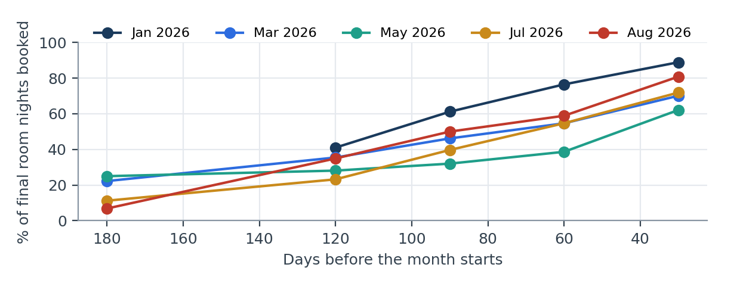
Figure 1 — Share of each 2026 month's final room nights already booked X days before the month started. Points before the initial reservation load (1-Sep-2025) are not observable.

4. 2027 Position at a Glance
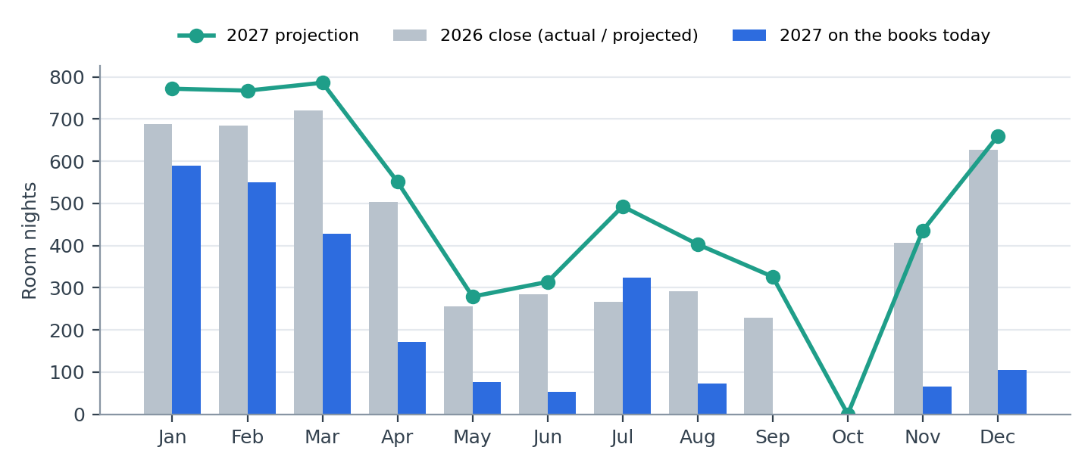
Figure 2 — Room nights by month: 2026 close, 2027 on the books today and 2027 projection.
Month | Cap. | OTB | Occ. | STLY | Pace | Blocks | 2026 | Proj. | Occ. | Revenue | vs 2026 | Conf.
Jan | 930 | 590 | 63% | 410 | 117% | 111 | 688 | 772 | 83% | $855,285 | −1% | High
Feb | 840 | 550 | 65% | 218 | 177% | 164 | 684 | 767 | 91% | $807,969 | +5% | High
Mar | 930 | 428 | 46% | 202 | 112% | 201 | 721 | 786 | 85% | $822,555 | +4% | Medium
Apr | 900 | 172 | 19% | 72 | 151% | 63 | 503 | 551 | 61% | $629,356 | +2% | Medium
May | 930 | 77 | 8% | 47 | 74% | 42 | 256 | 279 | 30% | $226,715 | +3% | Low
Jun | 900 | 53 | 6% | 10 | 110% | 42 | 284 | 314 | 35% | $180,467 | +18% | Low
Jul | 930 | 324 | 35% | 21 | 143% | 294 | 267 | 493 | 53% | $493,301 | +98% | Medium
Aug | 930 | 72 | 8% | 4 | 150% | 66 | 292 | 403 | 43% | $370,992 | +33% | Low
Sep | 900 | 0 | 0% | 3 | 0% | 0 | 229* | 326 | 36% | $61,234 | +42% | Low
Oct | 930 | 0 | 0% | 0 | — | 0 | 0 | 0 | 0% | $0 | — | No operation
Nov | 900 | 66 | 7% | 43 | 0% | 66 | 407* | 436 | 48% | $324,536 | +8% | Low
Dec | 930 | 105 | 11% | 5 | 0% | 105 | 627* | 660 | 71% | $623,542 | 0% | Low
Total | 10,950 | 2,437 | 22% | 1,035 | 124% | 1,154 | 4,958 | 5,786 | 53% | $5,395,951 | +10%
OTB = on the books today. STLY = on the books for the same month on 30-Sep-2025. Pace = individual reservations ÷ STLY (excludes group blocks). * = 2026 month not yet closed (projection used).
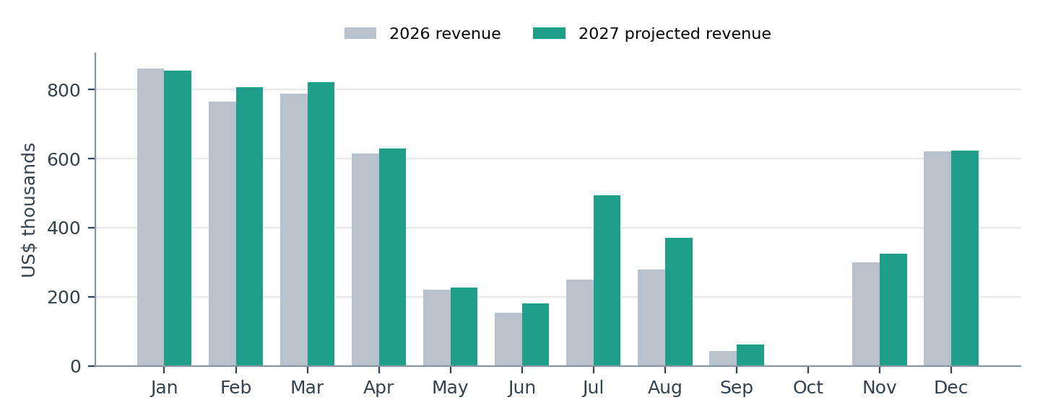
Figure 3 — Total revenue by month: 2026 versus 2027 projection (US$ thousands).
Seasonal reading
- High season (January–April): 2,876 RN and $3,115,165, 58% of the year's projected revenue. January–March is already 54–76% secured.
- Green season (May–September): 1,814 RN and $1,332,708. July is held up by a 294 RN group block. The other months are below 10% on the books today, which is normal for a late-booking property but needs commercial support.
- Year-end (November–December): 1,096 RN and $948,078. Only group blocks are on the books, and the 2026 reference for these months is still a projection.

5. Why the Projection Is a Reliable Planning Parameter
The projection is not a target and is not set by hand. It starts from the reservations already on the books and adds, month by month, only the share of free rooms that 2026 filled from the same date. Six pieces of evidence support it:
# | Evidence | What the data shows
1 | It comes from actual behaviour, not an assumption | Each month starts from what is already on the books and adds only the share of free rooms that 2026 filled from this same date. There are no hand-entered growth rates.
2 | The data reconciles | In the 8 closed months of 2026, the reservations (source of STLY and pace) add up to 99.6% of the room nights in Opera's History & Forecast.
3 | It is prudent against other methods | With the same data, three standard methods give: availability 5,786 RN · add pickup 6,212 RN · multiply by pace 8,498 RN. The projection used (availability) is the most conservative: it does not multiply the pace and cannot exceed available rooms.
4 | It asks for less than was already achieved | The pickup still needed (3,349 RN) is 85% of what 2026 achieved from the same date (3,923 RN).
5 | A large part is already secured | 2,437 of the 5,786 projected RN (42%) are already reservations on the books worth $2,253,556.
6 | It is scored month by month | Confidence by month: 2 high, 3 medium, 6 low (see 'Monthly analysis').

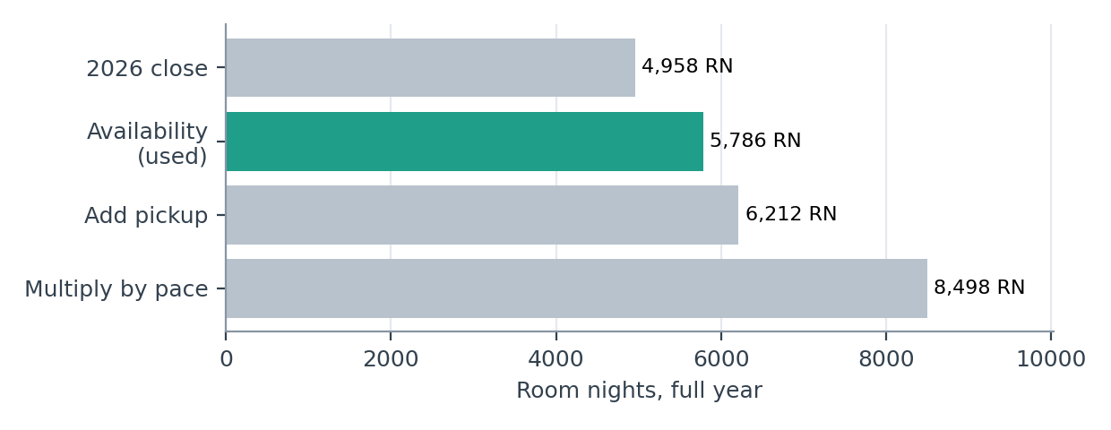
Figure 4 — Full-year 2027 room nights under three standard pacing methods, against the 2026 close. The method used is the lowest of the three.
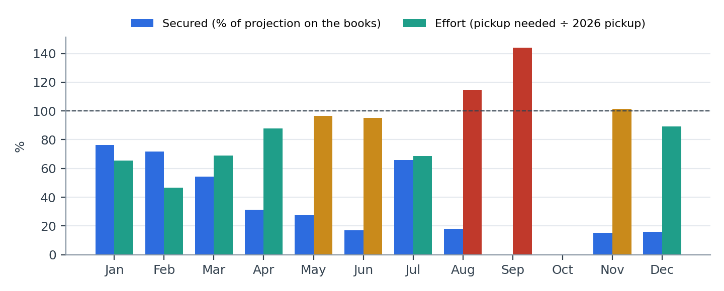
Figure 5 — Per month: share of the projection already on the books (blue) and effort required, i.e. pickup still needed ÷ pickup 2026 achieved from the same date (green ≤ 90%, amber 90–110%, red > 110%).
Limits the Board should be aware of
- 3 months of 2026 have not closed yet: their reference is the 2026 projection, not an actual.
- A full back-test (projecting a closed year and comparing) needs two years of reservation history; there is one today. As each month of 2027 closes, the method's accuracy can be measured.
- Prior-year pickup windows of 30 days or more include the initial reservation load and are not comparable.
- Revenue includes an estimate of on-site spend (12% of room revenue, a Finance assumption).

6. Month-by-Month Analysis
Each month shows its key figures, a Finance assessment, its strengths and risks, and recommended actions. Confidence scores how much of the month is secured, the effort it needs against 2026, whether the reference is an actual close, the pace, the weight of group blocks and the quality of the reference rate.

January 2027 Confidence: High
On the books | STLY | Pace | 2026 | Projection | Proj. occ. | Proj. revenue | Secured | RN to go | Effort
590 | 410 | 117% | 688 | 772 | 83.0% | $855,285 | 76% | 182 | 65%

590 room nights are on the books (63.4% occupancy) against 410 at the same date last year. The projection is 772 RN (83.0% occupancy) and $855,285 of revenue, +12% in nights and −1% in revenue versus January 2026 (actual close: 688 RN, $862,234).
To reach the projection 182 RN still need to be booked, about 10 per week until month-end. That is 65% of the 278 RN that January 2026 picked up from this same date — less than what was already achieved.
Strengths
- Individual reservations are ahead of last year: 479 vs 410 (pace 117%).
- 76% of the projection is already secured.
- Booked rate is $742 per night, 14.5% above the rate booked a year ago ($648).
- The pickup required is below what was achieved in 2026 from the same date.
Risks
- Cancellations: 130 RN cancelled so far (21% of what was booked), above last year's 12%.
- 27 RN are held with weak or no guarantee.
- 12 HOLD reservations (54 RN) are blocking inventory and should be confirmed or released.
Recommended actions
- Rate discipline on a high-demand month: hold or increase rates on peak dates and apply minimum-stay rules; do not discount to fill the last rooms.
- Review 15 reservations flagged for rate or guarantee issues (potential recovery $10,619–$15,021).
- Focus pickup on nights 29–31: the least-covered week, 54 RN booked against 76 RN sold in the same nights of 2026.
Top sources on the books
Source | RN today | Booked value | RN same date 2026 | 2026 final RN
Directo / sin agencia | 90 | $74,771 | 57 | 97
SERVICIO DE VIAJER | 44 | $28,878 | 83 | 91
AGENCIA DE VIAJES | 41 | $29,042 | 56 | 65
COSTA RICA SUN TOU | 9 | $5,317 | 0 | 81
SYX | 44 | $58,567 | 18 | 39

February 2027 Confidence: High
On the books | STLY | Pace | 2026 | Projection | Proj. occ. | Proj. revenue | Secured | RN to go | Effort
550 | 218 | 177% | 684 | 767 | 91.3% | $807,969 | 72% | 217 | 47%

550 room nights are on the books (65.5% occupancy) against 218 at the same date last year. The projection is 767 RN (91.3% occupancy) and $807,969 of revenue, +12% in nights and +5% in revenue versus February 2026 (actual close: 684 RN, $766,156).
To reach the projection 217 RN still need to be booked, about 10 per week until month-end. That is 47% of the 466 RN that February 2026 picked up from this same date — less than what was already achieved.
Strengths
- Individual reservations are ahead of last year: 386 vs 218 (pace 177%).
- 72% of the projection is already secured.
- Booked rate is $734 per night, 15.8% above the rate booked a year ago ($634).
- The pickup required is below what was achieved in 2026 from the same date.
Risks
- 164 RN (30% of the books) are group blocks without a rooming list; their release is the main swing factor.
- 3 HOLD reservations (10 RN) are blocking inventory and should be confirmed or released.
Recommended actions
- Rate discipline on a high-demand month: hold or increase rates on peak dates and apply minimum-stay rules; do not discount to fill the last rooms.
- Obtain rooming lists and confirm cut-off dates for the 164 RN of group blocks; release unconfirmed rooms to general sale on time.
- Review 13 reservations flagged for rate or guarantee issues (potential recovery $13,989–$25,601).
- Focus pickup on nights 8–14: the least-covered week, 122 RN booked against 184 RN sold in the same nights of 2026.
Top sources on the books
Source | RN today | Booked value | RN same date 2026 | 2026 final RN
SERVICIO DE VIAJER | 91 | $49,569 | 53 | 100
Directo / sin agencia | 49 | $29,040 | 24 | 108
COSTA RICA SUN TOU | 7 | $6,555 | 0 | 90
TRAVEL EXCELLENCE | 29 | $17,423 | 37 | 62
AGENCIA DE VIAJES | 20 | $13,166 | 35 | 56

March 2027 Confidence: Medium
On the books | STLY | Pace | 2026 | Projection | Proj. occ. | Proj. revenue | Secured | RN to go | Effort
428 | 202 | 112% | 721 | 786 | 84.5% | $822,555 | 54% | 358 | 69%

428 room nights are on the books (46.0% occupancy) against 202 at the same date last year. The projection is 786 RN (84.5% occupancy) and $822,555 of revenue, +9% in nights and +4% in revenue versus March 2026 (actual close: 721 RN, $788,508).
To reach the projection 358 RN still need to be booked, about 14 per week until month-end. That is 69% of the 519 RN that March 2026 picked up from this same date — less than what was already achieved.
Strengths
- Individual reservations are ahead of last year: 227 vs 202 (pace 112%).
- Booked rate is $663 per night, 14.1% above the rate booked a year ago ($581).
- The pickup required is below what was achieved in 2026 from the same date.
Risks
- 201 RN (47% of the books) are group blocks without a rooming list; their release is the main swing factor.
- 8 HOLD reservations (31 RN) are blocking inventory and should be confirmed or released.
Recommended actions
- Rate discipline on a high-demand month: hold or increase rates on peak dates and apply minimum-stay rules; do not discount to fill the last rooms.
- Obtain rooming lists and confirm cut-off dates for the 201 RN of group blocks; release unconfirmed rooms to general sale on time.
- Review 15 reservations flagged for rate or guarantee issues (potential recovery $10,796–$22,335).
- Focus pickup on nights 29–31: the least-covered week, 25 RN booked against 68 RN sold in the same nights of 2026.
Top sources on the books
Source | RN today | Booked value | RN same date 2026 | 2026 final RN
SERVICIO DE VIAJER | 57 | $29,482 | 45 | 94
Directo / sin agencia | 34 | $22,617 | 32 | 102
SYX | 15 | $15,246 | 0 | 68
COSTA RICA SUN TOU | 0 | $0 | 0 | 82
TRAVEL EXCELLENCE | 33 | $18,100 | 18 | 44

April 2027 Confidence: Medium
On the books | STLY | Pace | 2026 | Projection | Proj. occ. | Proj. revenue | Secured | RN to go | Effort
172 | 72 | 151% | 503 | 551 | 61.2% | $629,356 | 31% | 379 | 88%

172 room nights are on the books (19.1% occupancy) against 72 at the same date last year. The projection is 551 RN (61.2% occupancy) and $629,356 of revenue, +10% in nights and +2% in revenue versus April 2026 (actual close: 503 RN, $615,596).
To reach the projection 379 RN still need to be booked, about 13 per week until month-end. That is 88% of the 431 RN that April 2026 picked up from this same date — less than what was already achieved.
Strengths
- Individual reservations are ahead of last year: 109 vs 72 (pace 151%).
- Booked rate is $630 per night, 15.8% above the rate booked a year ago ($544).
- The pickup required is below what was achieved in 2026 from the same date.
Risks
- 63 RN (37% of the books) are group blocks without a rooming list; their release is the main swing factor.
- 1 HOLD reservation (4 RN) is blocking inventory and should be confirmed or released.
Recommended actions
- Balance volume and rate: keep the current rate strategy and open tactical offers only on the weakest weeks.
- Obtain rooming lists and confirm cut-off dates for the 63 RN of group blocks; release unconfirmed rooms to general sale on time.
- Review 3 reservations flagged for rate or guarantee issues (potential recovery $3,690).
Top sources on the books
Source | RN today | Booked value | RN same date 2026 | 2026 final RN
Directo / sin agencia | 11 | $6,230 | 10 | 101
TRAVEL PIONEERS S. | 0 | $0 | 12 | 111
SYX | 20 | $17,229 | 0 | 53
SERVICIO DE VIAJER | 18 | $10,145 | 6 | 23
CORPORACION DE VIA | 0 | $0 | 0 | 22

May 2027 Confidence: Low
On the books | STLY | Pace | 2026 | Projection | Proj. occ. | Proj. revenue | Secured | RN to go | Effort
77 | 47 | 74% | 256 | 279 | 30.0% | $226,715 | 28% | 202 | 97%

77 room nights are on the books (8.3% occupancy) against 47 at the same date last year. The projection is 279 RN (30.0% occupancy) and $226,715 of revenue, +9% in nights and +3% in revenue versus May 2026 (actual close: 256 RN, $220,797).
To reach the projection 202 RN still need to be booked, about 6 per week until month-end. That is 97% of the 209 RN that May 2026 picked up from this same date — less than what was already achieved.
Risks
- Booked rate is $599 per night, 7.5% below the rate booked a year ago ($648).
- Individual reservations are behind last year: 35 vs 47 (pace 74%).
- 42 RN (55% of the books) are group blocks without a rooming list; their release is the main swing factor.
- 1 HOLD reservation (5 RN) is blocking inventory and should be confirmed or released.
Recommended actions
- Need-period plan: targeted offers through the main agencies and wholesalers, package promotions and direct campaigns, launched at least 90 days before arrival.
- Obtain rooming lists and confirm cut-off dates for the 42 RN of group blocks; release unconfirmed rooms to general sale on time.
- Review 1 reservation flagged for rate or guarantee issues (potential recovery $840).
Top sources on the books
Source | RN today | Booked value | RN same date 2026 | 2026 final RN
Directo / sin agencia | 11 | $7,094 | 0 | 47
SYX | 0 | $0 | 10 | 49
SERVICIO DE VIAJER | 11 | $5,011 | 14 | 22
TRAVEL EXCELLENCE | 6 | $3,583 | 3 | 20
COSTA RICA SUN TOU | 0 | $0 | 0 | 22

June 2027 Confidence: Low
On the books | STLY | Pace | 2026 | Projection | Proj. occ. | Proj. revenue | Secured | RN to go | Effort
53 | 10 | 110% | 284 | 314 | 34.9% | $180,467 | 17% | 261 | 95%

53 room nights are on the books (5.9% occupancy) against 10 at the same date last year. The projection is 314 RN (34.9% occupancy) and $180,467 of revenue, +10% in nights and +18% in revenue versus June 2026 (actual close: 284 RN, $153,239).
To reach the projection 261 RN still need to be booked, about 7 per week until month-end. That is 95% of the 274 RN that June 2026 picked up from this same date — less than what was already achieved.
Strengths
- Individual reservations are ahead of last year: 11 vs 10 (pace 110%).
Risks
- 42 RN (79% of the books) are group blocks without a rooming list; their release is the main swing factor.
Recommended actions
- Need-period plan: targeted offers through the main agencies and wholesalers, package promotions and direct campaigns, launched at least 90 days before arrival.
- Obtain rooming lists and confirm cut-off dates for the 42 RN of group blocks; release unconfirmed rooms to general sale on time.
Top sources on the books
Source | RN today | Booked value | RN same date 2026 | 2026 final RN
Directo / sin agencia | 3 | $1,534 | 0 | 95
THE COSTA RICA COL | 0 | $0 | 0 | 32
SYX | 3 | $3,923 | 0 | 26
COSTA RICA SUN TOU | 0 | $0 | 0 | 27
SERVICIO DE VIAJER | 0 | $0 | 10 | 16

July 2027 Confidence: Medium
On the books | STLY | Pace | 2026 | Projection | Proj. occ. | Proj. revenue | Secured | RN to go | Effort
324 | 21 | 143% | 267 | 493 | 53.0% | $493,301 | 66% | 169 | 69%

324 room nights are on the books (34.8% occupancy) against 21 at the same date last year. The projection is 493 RN (53.0% occupancy) and $493,301 of revenue, +85% in nights and +98% in revenue versus July 2026 (actual close: 267 RN, $248,598).
To reach the projection 169 RN still need to be booked, about 4 per week until month-end. That is 69% of the 246 RN that July 2026 picked up from this same date — less than what was already achieved.
Strengths
- Individual reservations are ahead of last year: 30 vs 21 (pace 143%).
- 66% of the projection is already secured.
- The pickup required is below what was achieved in 2026 from the same date.
Risks
- 294 RN (91% of the books) are group blocks without a rooming list; their release is the main swing factor.
Recommended actions
- Balance volume and rate: keep the current rate strategy and open tactical offers only on the weakest weeks.
- Obtain rooming lists and confirm cut-off dates for the 294 RN of group blocks; release unconfirmed rooms to general sale on time.
- Focus pickup on nights 29–31: the least-covered week, 2 RN booked against 21 RN sold in the same nights of 2026.
Top sources on the books
Source | RN today | Booked value | RN same date 2026 | 2026 final RN
COSTA RICA SUN TOU | 3 | $2,021 | 0 | 56
Directo / sin agencia | 0 | $0 | 5 | 45
SYX | 0 | $0 | 0 | 29
TRAVEL EXCELLENCE | 0 | $0 | 0 | 23
AGENCIA DE VIAJES | 0 | $0 | 16 | 20

August 2027 Confidence: Low
On the books | STLY | Pace | 2026 | Projection | Proj. occ. | Proj. revenue | Secured | RN to go | Effort
72 | 4 | 150% | 292 | 403 | 43.3% | $370,992 | 18% | 331 | 115%

72 room nights are on the books (7.7% occupancy) against 4 at the same date last year. The projection is 403 RN (43.3% occupancy) and $370,992 of revenue, +38% in nights and +33% in revenue versus August 2026 (actual close: 292 RN, $278,054).
To reach the projection 331 RN still need to be booked, about 7 per week until month-end. That is 115% of the 288 RN that August 2026 picked up from this same date — more than last year achieved, so the month needs additional commercial effort.
Strengths
- Individual reservations are ahead of last year: 6 vs 4 (pace 150%).
Risks
- 66 RN (92% of the books) are group blocks without a rooming list; their release is the main swing factor.
- The projection requires 115% of last year's pickup from this date.
Recommended actions
- Need-period plan: targeted offers through the main agencies and wholesalers, package promotions and direct campaigns, launched at least 90 days before arrival.
- Obtain rooming lists and confirm cut-off dates for the 66 RN of group blocks; release unconfirmed rooms to general sale on time.
Top sources on the books
Source | RN today | Booked value | RN same date 2026 | 2026 final RN
Directo / sin agencia | 0 | $0 | 4 | 54
COSTA RICA SUN TOU | 0 | $0 | 0 | 43
RUSS TICO TRAVEL D | 0 | $0 | 0 | 36
SYX | 0 | $0 | 0 | 24
AGENCIA DE VIAJES | 0 | $0 | 0 | 21

September 2027 Confidence: Low
On the books | STLY | Pace | 2026 | Projection | Proj. occ. | Proj. revenue | Secured | RN to go | Effort
0 | 3 | 0% | 229* | 326 | 36.2% | $61,234 | 0% | 326 | 144%

0 room nights are on the books (0.0% occupancy) against 3 at the same date last year. The projection is 326 RN (36.2% occupancy) and $61,234 of revenue, +42% in nights and +42% in revenue versus September 2026 (still a projection: 229 RN, $43,019).
To reach the projection 326 RN still need to be booked, about 6 per week until month-end. That is 144% of the 226 RN that September 2026 picked up from this same date — more than last year achieved, so the month needs additional commercial effort.
Risks
- Individual reservations are behind last year: 0 vs 3 (pace 0%).
- The projection requires 144% of last year's pickup from this date.
- The September 2026 reference has not closed yet; it is itself a projection.
- The prior-year value per night used for this month ($188) is atypical against the year average ($933); September 2026 revenue in Opera should be reviewed before relying on the revenue figure.
Recommended actions
- Need-period plan: targeted offers through the main agencies and wholesalers, package promotions and direct campaigns, launched at least 90 days before arrival.
- Finance to review the September 2026 revenue posted in Opera (value per night far below the year average).

October 2027 Confidence: No operation
October 2027 has no room nights on the books, no prior-year activity and no projection. The lodge is expected to remain closed, consistent with October 2026.
Recommended actions
- Confirm the closure dates are blocked in Opera and on all distribution channels.

November 2027 Confidence: Low
On the books | STLY | Pace | 2026 | Projection | Proj. occ. | Proj. revenue | Secured | RN to go | Effort
66 | 43 | 0% | 407* | 436 | 48.4% | $324,536 | 15% | 370 | 102%

66 room nights are on the books (7.3% occupancy) against 43 at the same date last year. The projection is 436 RN (48.4% occupancy) and $324,536 of revenue, +7% in nights and +8% in revenue versus November 2026 (still a projection: 407 RN, $299,890).
To reach the projection 370 RN still need to be booked, about 6 per week until month-end. That is 102% of the 364 RN that November 2026 picked up from this same date — more than last year achieved, so the month needs additional commercial effort.
Risks
- Everything on the books (66 RN) is group blocks; there are no individual reservations yet, versus 43 a year ago.
- The November 2026 reference has not closed yet; it is itself a projection.
Recommended actions
- Balance volume and rate: keep the current rate strategy and open tactical offers only on the weakest weeks.
- Obtain rooming lists and confirm cut-off dates for the 66 RN of group blocks; release unconfirmed rooms to general sale on time.
- Verify that 2027 rates and inventory for this month are loaded and open for sale on every channel (Opera, website, agencies, OTAs).

December 2027 Confidence: Low
On the books | STLY | Pace | 2026 | Projection | Proj. occ. | Proj. revenue | Secured | RN to go | Effort
105 | 5 | 0% | 627* | 660 | 71.0% | $623,542 | 16% | 555 | 89%

105 room nights are on the books (11.3% occupancy) against 5 at the same date last year. The projection is 660 RN (71.0% occupancy) and $623,542 of revenue, +5% in nights and +0% in revenue versus December 2026 (still a projection: 627 RN, $621,378).
To reach the projection 555 RN still need to be booked, about 8 per week until month-end. That is 89% of the 622 RN that December 2026 picked up from this same date — less than what was already achieved.
Strengths
- The pickup required is below what was achieved in 2026 from the same date.
Risks
- Everything on the books (105 RN) is group blocks; there are no individual reservations yet, versus 5 a year ago.
- The December 2026 reference has not closed yet; it is itself a projection.
Recommended actions
- Balance volume and rate: keep the current rate strategy and open tactical offers only on the weakest weeks.
- Obtain rooming lists and confirm cut-off dates for the 105 RN of group blocks; release unconfirmed rooms to general sale on time.
- Verify that 2027 rates and inventory for this month are loaded and open for sale on every channel (Opera, website, agencies, OTAs).

7. Total Revenue Opportunities
Above the projection, the open months still have 4,234 unsold room nights. Two levers are quantified for each month at its projected value per night. Each extra 5 occupancy points is worth about $434,805 for the year. Each extra 5% of rate on the room nights still to be sold is worth about $144,319.
Month | Proj. occ. | Unsold nights | +5 pts occupancy (RN) | Value +5 pts | Value +5% rate | Booked rate vs 2026
Jan | 83.0% | 158 | 47 | $51,532 | $10,072 | +14.5%
Feb | 91.3% | 73 | 42 | $44,228 | $11,440 | +15.8%
Mar | 84.5% | 144 | 47 | $48,670 | $18,729 | +14.1%
Apr | 61.2% | 349 | 45 | $51,404 | $21,644 | +15.8%
May | 30.0% | 651 | 47 | $37,799 | $8,206 | −7.5%
Jun | 34.9% | 586 | 45 | $25,883 | $7,499 | —
Jul | 53.0% | 437 | 47 | $46,544 | $8,450 | —
Aug | 43.3% | 527 | 47 | $42,829 | $15,234 | —
Sep | 36.2% | 574 | 45 | $8,454 | $3,062 | —
Nov | 48.4% | 464 | 45 | $33,517 | $13,769 | —
Dec | 71.0% | 270 | 47 | $43,945 | $26,216 | —
Total | 52.8% | 4,234 | 501 | $434,805 | $144,319

Where the upside is
- Value per night. If 2027 sells each month at 2026's value per night, revenue would be $5,648,801 instead of $5,395,951: +$252,850 with no extra room nights. Booked rates for January–April are already 14–16% above a year ago, which supports this.
- Shoulder and green season. May, June, August and September are projected at 30–43% occupancy, against 74–91% in the high season. Each 5 occupancy points in these four months is worth about $114,964.
- Group blocks. 1,154 RN are blocked without rooming lists. Converting them on time protects the base; releasing them early enough lets the rooms be resold at transient rates.
- Reservation clean-up. The flagged reservations (rate below the month median, per-person rates, missing guarantees, HOLD profiles) represent recoverable revenue in January–April. Section 6 lists them month by month.

8. Risks and Watch List
Risk | Months | What we see | Mitigation
Slower recent booking pace | All | Last 14 days: 72 RN booked for 2027 vs 102 in the same window last year (−29%). | Track weekly; trigger agency and direct campaigns if the trend holds for 4 weeks.
Group block attrition | Feb, Mar, Jul, Nov, Dec | 1,154 RN of blocks; up to 91% of July and 100% of Nov–Dec books. | Rooming-list deadlines, deposits, cut-off dates; release unconfirmed rooms to sale.
Year-end not yet open for sale? | Nov, Dec | No individual reservations vs 43 and 5 a year ago. | Verify 2027 rates and inventory are loaded on all channels.
Higher cancellations | Jan | 130 RN cancelled (21% of booked) vs 12% last year. | Review deposit and cancellation terms with agencies.
Need periods | May, Jun, Aug, Sep | Projected 30–43% occupancy; August and September require more pickup than 2026 achieved. | Green-season offers launched at least 90 days before arrival.
Room revenue overstated in the budget | All | Nights at $0 were 14% of 2026 occupancy; budget net rate is applied per occupied night. | Add a monthly allowance for comps and $0 nights to the 2027 budget.
Revenue data quality | Sep | September 2026 at $188 per night distorts the September 2027 revenue projection. | Finance to review the revenue posted in Opera.
Prior-year reference still projected | Sep, Nov, Dec | These 2026 months have not closed; their reference is a projection. | Re-run the analysis as each month closes.

9. Recommended Action Plan (next 90 days)
- Rooms: set a monthly ADR target per villa type based on the 2026 actual and Forecast ADR, review it weekly against Opera, and cap comps, house use and FAM nights.
- Revenue: set the high-season rate grid (January–April 2027) to protect value per night, with minimum stays on peak dates and no discounting on months above 80% projected occupancy.
- Sales: get rooming lists and deposit schedules for all group blocks (1,154 RN) and agree release dates, starting with February and March.
- Distribution: confirm that November–December 2027 rates and inventory are open on Opera, the website, agencies and OTAs.
- Marketing: launch a green-season plan (May–June, August–September) with key agencies and wholesalers, direct campaigns and packages, at least 90 days before arrival.
- Reservations: clean up the flagged reservations and HOLD profiles listed in Section 6.
- Budget: separate the rates for Carate vs Corcovado and Agujas vs Sirena, and add a monthly allowance for comps and $0 nights to the 2027 room revenue.
- Finance: correct September 2026 revenue in Opera, upload a new Opera snapshot every month and report to the Board how the projection compares with each actual close.

Appendix A — Methodology and Glossary
On the books (OTB): Room nights reserved today according to Opera's History & Forecast; includes group blocks.
STLY: Same Time Last Year: what was on the books for the same month on 30 September 2025, taken from the reservation file.
Pace: Individual reservations today ÷ STLY. Above 100% means ahead of last year.
Group blocks: Group room nights in the History & Forecast that do not yet have individual reservations (no rooming list).
Availability method (used): Projection = on the books + 2026 fill rate × rooms still free. It is capped at the rooms available.
Add pickup method: Projection = on the books + the room nights 2026 picked up from the same date.
Multiply by pace method: Projection = on the books × (2026 close ÷ STLY). It amplifies pace, so it is the most aggressive.
Effort: Pickup still needed ÷ pickup 2026 achieved from the same date.
Secured: Share of the projection already on the books.
Revenue: Booked revenue for the nights on the books, plus the projected nights valued at the prior-year value per night. On-site spend is estimated at 12% of room revenue.
Confidence: +2 if 60% or more is secured (+1 if 30–60%). +2 if effort is 90% or less (+1 if up to 110%). +1 if the reference is an actual close. +1 if pace is 100% or more. −1 or −2 if group blocks exceed 25% or 50% of the books. −1 if the reference rate is atypical. High is 5 or more, medium 3–4, low 2 or less.

Appendix B — Projection by Method, per Month
Month | Availability (used) | Add pickup | Multiply by pace | 2026 close | Revenue (used)
January | 772 | 868 | 930 | 688 | $855,285
February | 767 | 840 | 840 | 684 | $807,969
March | 786 | 930 | 930 | 721 | $822,555
April | 551 | 603 | 900 | 503 | $629,356
May | 279 | 286 | 419 | 256 | $226,715
June | 314 | 327 | 900 | 284 | $180,467
July | 493 | 570 | 930 | 267 | $493,301
August | 403 | 360 | 930 | 292 | $370,992
September | 326 | 226 | 0 | 229 | $61,234
October | 0 | 0 | 0 | 0 | $0
November | 436 | 455 | 789 | 407 | $324,536
December | 660 | 747 | 930 | 627 | $623,542
Total | 5,786 | 6,212 | 8,498 | 4,958 | $5,395,951

Appendix C — Data Sources
- Opera History & Forecast, Total Revenue and Rooms Only, as of 30-Sep-2026 (2026 actuals and 2027 on the books).
- Opera Reservations Entered On, 1-Sep-2025 to 30-Sep-2026: 2,682 reservations. Source of STLY, pace, rates, channels and cancellations. The 1-Sep-2025 load is the system migration date.
- 2026 Financial Forecast: P&L Full Year Forecast SCP CWL 2026 (January–March actual, April–December forecast), loaded in FinPlan as the 2026 target: 4,483 RN, $5,040,287 total revenue.
- 2027 room rates: BUDGET Working 2027 Net Rate in FinPlan (rack × net factor 0.797).
- All figures come from FinPlan → Pacing (Position and Technical Analysis), which recalculates with every new Opera upload.

